Internal Community Room Guidelines & Procedures

Last Updated: | November 1, 2022
Written By: | Mikala D. Geurtsen
Edited By: | Hanna L. Sanders

Table of Contents
Summary of Changes 3
General Information 4
Guidelines 4
Booking the Community Room 4
External Organization 4
Request via Online Form 4
Request via Email 5
Request via Phone 5
Employees Booking the Community Room 6
Booking Conflicts 6
Weekend Bookings 6
Exterior Door PIN Assignment 6
Accessing Citadel (PIN Software) 6
Creating PIN for a New Organization 6
To Add a New Time Period 7
To Create a User Group 7
To Create Privileges 7
To Add a Card (PIN) 7
Enable PIN 8
Disable PIN 8
Communication Upload 8
Exiting Citadel 8
Returning Organizations 8
Room Communication Protocol 9
Smartsheet Responsibility breakdown: 9
To set alerts on the sheet 9
Alerts to be Set 9
Reoccurring Meeting Procedures 10
Requesting Updates 10
Appointed Bank Representatives 12
Emergency Contact Procedure 13
Email templates 14
Booking Confirmation Template 14
Booking Conflict Template 15
Reminder Email Template 16
Replying to an Email Request Template 18
After Meeting Thank You Template 19
Phone Request Room Setup Sheet 20
Room Setups 21
Long Meeting Table 21
Classroom Style Table Rows 22
U-Shaped Table 23
Chair Rows, No Table 24
Room Guidelines 25
General Guidelines on Website 25
In Room Guidelines 25
In Room Device Guide 25
Room Contacts 26

Summary of Changes

Section | Change
Guidelines | - Grammatical errors corrected  - Business hours updated  - Changed Community Room Coordinator to be responsible for contacting and meeting with new organizations to review guidelines  - Changed Conference Room Administrator to be responsible for sending after meeting email  - Added item regarding new employees to direct any one from an outside organization to the website to request Community Room
Booking the Community Room | - Grammatical errors corrected  - Added new program features Sicunet Neptune that changed from Citadel
Weekend Bookings | - Removed line stating a bank representative needs to check the room between bookings on the weekend and updated information to reflect a facilities representative will come to change the room layout, if needed
Exterior Door PIN Assignment | - Updated business hours
Returning Organizations | - Updated section to define returning organizations as those that use the room on a regular basis
Room Communication Protocol | - Grammatical errors corrected
Smartsheet Responsibility Breakdown | - Removed Community Outreach Coordinator and added Community Room Coordinator
Requesting Updates | - Added that the Conference Room Administrator is responsible for sending out update requests as needed
Appointed Bank Representatives | - Added the Community Room Coordinator is responsible is contact for during hours events and the After Hours Contact is responsible for after-hours events.
Emergency Contact Procedure | - Updated chart to further differentiate procedures for both during and after hours.
Page 6 | - Updating/Setting PIN
Page 7 | - Adding cards, deleting user groups, deleted privileges, deleted Citadel
Room Contacts | - Updated roles and contact information

General Information
The community room was created to help support local events and non -profit organizations. We want to continue to see local organizations and community programs flourish. The room is also available for internal use by employees for meetings.

Guidelines
- The community room is available to external organization between the hours of 8:00 am -10:00 pm, 7 days a week.
- The community room is available for employee bookings prior to 8:00 am.
- Business hours are defined at 8:30 am – 4:00 pm Monday through Wednesday, 8:30 am – 6:00 pm Thursday and Friday, and 8:30 am – 12:00 pm on Saturday.
- Written guidelines that include general rules of the room and safety and security are available on the community room page via Avidia Bank’s website.
- The Conference Room Administrator monitors requests for the room Monday-Friday 8-4pm.
- Employee requests to book this room must be requested in Outlook. No other method of reservation will be accepted.
- Organizations with after hour’s events will have a PIN assigned to them to access the room.
- If an organization is new to using the Community Room it is required that the Community Room Coordinator will contact the organization’s primary contact to schedule a time to meet in the Community Room to review the room guidelines.
- A follow-up email will be sent to the new organization five days after the event by the Community Room Coordinator.
- Employees should not book the Community Room through Outlook for external organizations. Instead, they should be directing the contact of that organization to the bank’s website to fill out the request form.

Booking the Community Room

External Organization
External organizations are considered to be any local community and/or nonprofit organization.

Request via Online Form
The online form is located on the bank’s website. When the form is complete and submitted to the bank it will arrive in the community room mailbox (communityroom@avidiabank.com). The process for booking the room begins:
- The conference room administrator reviews the Community Room’s calendar via Outlook to ensure the date/time requested is open. If the room is unavailable see procedure Booking Conflicts
- Ensure online document is completed in its entirety. If not, when sending the Booking Confirmation email template, include a request for the missing information.
- Book the room via the Outlook calendar.
- If event is after hours assign a PIN. See procedure-Assigning a PIN for more information.
- Access the Community Room Smartsheet and enter in all applicable information.
- Send the Booking Confirmation email template once data is entered into Smartsheet.
- Three days prior to event Activate PIN in Citadel software.
- Send Reminder email template two days prior to event

Request via Email
An organization may email the Community Room directly to reserve the room. When an email is received the booking process begins:
- Respond to the email using the Replying to an email request template. Refer to template for information on date/time and PIN.
- If date/time was included in initial email
  - If date is available-book the room via the Outlook calendar
  - If date is unavailable – Reply to the organization using the Booking Conflict email template.
- Ensure the organization’s contact has sent back the information originally requested 5 days prior to event. If information is not received, contact the organization and obtain the necessary information.
- If event is after hours assign a PIN. See procedure-Assigning a PIN for more information.
- Access the Community Room Smartsheet and enter in all applicable information.
- Send the Booking Confirmation email template once data is entered into Smartsheet.
- Three days prior to event Activate PIN in Citadel software.
- Send Reminder email template two days prior to event

Request via Phone
Organization may contact the bank to reserve the Community Room via phone. This call must be transferred to the Conference Room Administrator for booking. No other employees may complete this process. Once the call is transferred to the Administrator the booking process begins:
- Obtain the date/time the organization is requesting.
- While the caller is on the phone confirm that the room is available via Outlook.
  - If room is booked- inform the caller. Ask if another date would work. If an alternative date is not feasible inform the caller a call back is required to try to accommodate their request. See procedure- Booking Conflict.
  - If room is available- Gather from the caller, the booking information using the Phone Request Room Set up Sheet.
- Book the room via the Outlook calendar.
- If event is after hours assign a PIN. See procedure- Assigning a PIN for more information.
- Access the Community Room Smartsheet and enter in all applicable information.
- Send the Booking Confirmation email template once data is entered into Smartsheet.
- Three days prior to event and Activate PIN in Citadel software.
- Send Reminder email template two days prior to event.

Employees Booking the Community Room
When an employee needs to book the Community Room, for internal bank purposes, they should do so via Outlook as they would any other conference room within the Bank. Should an employee be asked by a customer to book the room for an external organization they should refer the customer to the web form or contact the Conference Room Administrator for further assistance. Employees should not book the Community Room via Outlook for a customer.

Booking Conflicts
The bank will book the room on a first come, first served basis but will try to accommodate when possible.
- Determine if the room is booked by an employee for a meeting.
  - Yes- Contact the employee and uncover if their meeting can be moved to another conference room based on the meeting needs (number of attendees and audio visual equipment needed).
    - Book the new conference room on their behalf and cancel the original booking.
    - Contact the organization and confirm that the Community Room is available.
    - Continue the booking process using the applicable procedure above.
  - No- If another organization has booked the room, contact the requesting organization using the Booking Conflict email template.

Weekend Bookings
In the event that there are multiple events booked in the Community Room over a weekend, the appointed facilities contact will be responsible for the new set up if needed. Contact the Community Room Administrator to organize any further action should it be required.

Exterior Door PIN Assignment
The Community Room may be accessed without a PIN during open business hours, 8:30 am – 4:00 pm Monday through Wednesday, 8:30 am – 6:00 pm Thursday and Friday, and 8:30 am – 12:00 pm on Saturday If the event falls outside of normal business hours, a PIN number is assigned to the organization. This PIN will allow them to gain access to the room and no other location within the Financial Center.

Accessing Sicunet Neptune (PIN Software)
- Use the web address https://10.172.131.43/.
- Log in with your network ID and network password.
- Enter your user ID and password provided.

Creating PIN for a New Organization
- Select the “New” option and enter in the credentials asked for. (example: last name: that is always the organization name, first name: that is always the point of contact, card info is entered is the are a brand new organization)
- Card Info is used to add the desired pin and to activate and deactivate the pin to enter the room.
- Always remember to unselect the “never expired” option for every organization.
- Once saved, the pin is enabled or disabled for the date you entered.

To Add a Card (PIN)
- Click Edit/Cards/Single
- Select Location/OK
- Click Record/Add or use the green plus sign within the icon bar
- Update the following fields:
  - Format Name = Location
  - Card Number = This is the PIN that will enter the door.
  - Last Name = Organization Name
  - First Name = First and Last Name of User
  - Selected date will be the date the pin is enabled.
- Click: OK

Enable PIN
Perform this action three prior to event.
- Click Edit/Cards/Single
- Select Location/OK
- Locate organization within list double click
- In the User group drop down select organization or last name of contact.
- Click Apply/OK.

Disable PIN
Perform this action the day after the event.
- Click Edit/Cards/
- Select Location/OK
- Locate organization within list double click
- Update the date that you wish the pin to not work for.
- Click Apply/OK.

Communication Upload
This step will send all information to the PIN pad at the Community Room door.
- Click: Communication /Reload Site
  - Perform Upload Before Refreshing? / YES / All Enabled /OK
- Click: Communication / Upload Transactions / All Sites /OK

Returning Organizations

Organizations that utilize the Community Room on a regular basis will be able to use the same PIN each time they use the room. Ensure the organization knows their PIN and enable their access privileges.

- Confirm the time period in which the organization is requesting the room is assigned to the organization in Citadel. See section – To Add a New Time Period for guidance
- Confirm the organization is within the correct User Group. See section – To Create a User Group for guidance
- Confirm with the organization that they know their PIN. To find their PIN within Sicunet click edit/card/selection location/ok. Locate the organization in the list, double click to open. The PIN is the number located in the “Card Number” field. Omit the preceding zero and remind the organization when entering their PIN to use their four digit PIN followed by *.
- A day before days prior to next event enable PIN see procedure Enable PIN.
- If time needs to be Changed
- Find time period # (go to privileges to find time period #)
- Double click
- Update time

Room Communication Protocol
Smartsheet is utilized to create a central collaboration forum in regards to all room bookings. The Conference Room Administrator will enter room reservation information into Smartsheet.
Once data is entered on the Smartsheet, all authorized users will receive an email alert of a new item.
All authorized users are then required to access Smartsheet and complete their applicable sections.
It is required that all authorized user set alerts on tasks they will own on the sheet.

Smartsheet Responsibility breakdown:
The top row of the Smartsheet displays which department is responsible for that column.
Title | Smartsheet Anonym
Conference Room Administrator | CRA
Community Room Coordinator | CRC
Facilities | FAC

To set alerts on the sheet
To set an alert on a cell you are responsible for
- Right click on the cell.
- Choose Row actions.
- Choose set reminders on the menu.
- Name: Choose the name of the responsible party.
- ON: Choose days before or days After due date
- Date: Choose a date
- Click Save

Alerts to be Set
The following alerts should be set up in Smartsheet:
- PIN setup completed (if meeting is after hours)
- PIN enabled
- PIN disabled
- Reminder email sent
- After meeting follow up email
- Contacts for event; Day of Event Contact and Facilities( if after hours)

Reoccurring Meeting Procedures
The Conference Room Administrator will create a new row within Smartsheet for reoccurring meetings. The new row is created after completion of the previous meeting.
- Copy a row that includes existing meeting information for that organization
- Paste in the next available row
- Delete the following in the new row:
  - PIN Enabled
  - PIN Disabled
  - Day of event bank contact
  - Room set up complete
  - Facilities Contact
  - Room check complete

Requesting Updates
If you need information from another team member that is not listed within the smartsheet, you can request an update. The person receiving the request will receive an email and from the email, they can click on the link to “open update form”. This will open a web page that will display a web form. The information requested can be completed within the web form and it will automatically be transferred to the community room smartsheet.
The Conference Room Administrator will check one week prior to the event to ensure the Day of Contact and Facilities Contact has been entered. If they have not been entered use the Update Request function to send a reminder.
- Highlight the row that requires an update
- Click on Update Requests at the bottom of the page
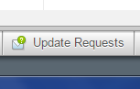
- Click on Create New Request…
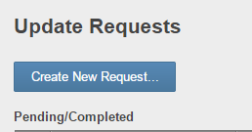
- Enter who will be receiving the request
- Update the Subject Line, if needed
- Update the message section with the reason why you are requesting the update
- In the customize section, click on edit
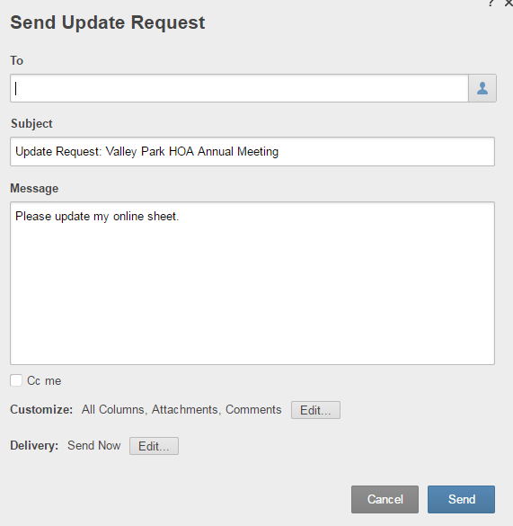
- Uncheck everything listed by clicking on All, this will clear all the check marks so that you can check off only the ones needed
- Always check the Organization, Date of Meeting, Start and End Time line items as this will ensure that the person receiving the request knows which meeting requires an update
- Check off the items you are requesting an update on
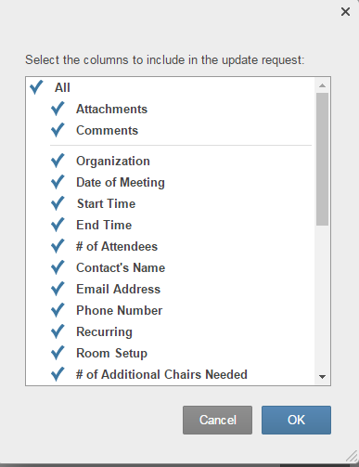
- Click OK
- Click Send

Appointed Bank Representatives
The Community Room Coordinator or an appointed bank representative is assigned to every during hours event.
A member of the facilities department and either the After Hours Contact or an appointed bank representative is assigned to every after hours Community Room event in the Smartsheet.
The name of the representative must be in the sheet no later than 3 days before the event date.
Once the event is over, in Smartsheet, the Conference Room Administrator will move the event line to the completed section of the sheet.

Emergency Contact Procedure

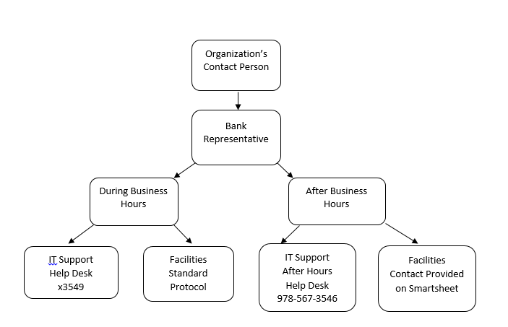

Email templates

Booking Confirmation Template
When using this template, ensure that the Community Room Welcome_Website file is attached to the email.
<Name of Contact>,

Thank you for choosing Avidia Bank’s Community Room to host your event. This is a confirmation of your booking request.

Date/Time: <***>
Number of Attendees: <***>
Room Setup: <***>
PIN Selected: <***> (Only include if meeting is taking place after hours)

(If New Organization)
Our Community Room Coordinator will be contacting you within the next few days to schedule a meeting so that you can see the room and review the room guidelines.

(Use when meeting is during business hours)

Parking is available in the Avidia Financial Center parking lot located on Church Street, but only allowed along the hedges. Other parking is available on Pope Street, Church Street, and Railroad Ave. Your group can enter through the front door of the parking lot. The Community Room is located through the glass double doors, after the staircase on the right.

(Use when meeting is after business hours)

Parking is available in the Avidia Financial Center parking lot located on Church Street, but only allowed along the hedges. Other parking is available on Pope Street, Church Street, and Railroad Ave. Enter the room through the Community Room door which is located on the right side of the building. The keypad is located to the right of the door. Enter your four digit PIN and asterisk (*). The light will change from green to red and the door will unlock.

Attached please find our room guidelines for review.

If you have any questions, please do not hesitate to contact me.

Thank you,
<Name>

Booking Conflict Template
<Name>,

Thank you for your interest in utilizing Avidia Bank’s Community Room for your event. Unfortunately, the date you have requested is unavailable. We do have other available dates, if you are flexible in the date and time of your event, please let us know so that we may accommodate your group’s event.

Please contact us by replying to this email or you can reach me by phone at 978-567-3502.

Thank you,
<Name>

Reminder Email Template
When using this template, ensure that the Community Room Welcome Website file is attached to the email.
<Name of Contact>,
The event you booked at Avidia Bank’s Community Room is coming up! Just a reminder of some housekeeping items.
The PIN you selected is: <***> (Only include if meeting is taking place after hours)

Your PIN will be active 30 minutes before & after the time in which you’ve booked the room.

(Use when meeting is during business hours)

Parking is available in the Avidia Financial Center parking lot located on Church Street, but only allowed along the hedges. Other parking is available on Pope Street, Church Street, and Railroad Ave. Your group can enter through the front door. The Community Room is located through the glass double doors, after the staircase on the right.

Please note when connecting to the Presentation Pod using WiFi(more detailed instructions are in the room), the TV input Source must be set to HDMI 2.
The WiFi name is AvidiaPres. The WiFi password Pr3sent!.

(Use when meeting is after business hours)

Parking is available in the Avidia Financial Center parking lot located on Church Street, but only allowed along the hedges. Other parking is available on Pope Street, Church Street, and Railroad Ave. Enter the room through the Community Room door which is located on the right side of the building. The keypad is located to the right of the door. Enter your four digit PIN and asterisk (*). The light will change from green to red and the door will unlock.

Please note when connecting to the Presentation Pod using WiFi(more detailed instructions are in the room), the TV input Source must be set to HDMI 2.
The WiFi name is AvidiaPres. The WiFi password Pr3sent!.

Should you have any trouble with anything, your bank contact for the day of your event is <name>. <She/He> can be reached at <phone number>.

If you have any questions, please do not hesitate to contact me.

Thank you,
<Name>

Replying to an Email Request Template

<Name>,

Thank you for your interest in Avidia Bank’s Community Room. The date you have requested is available but we need a little more information from you. Please complete the following:

Your Phone Number:
Date/Time Requested: (*include this line if date/time was not provided in initial email*)
Organization/Event Purpose:
Is the Organization based in Hudson?:
Are you or the organization a customer of Avidia Bank?:
Number of Attendees:
Requested Room Setup (please see attached layouts):
Select a 4 Digit PIN for Room Access: (*include this line if time requested is after hours or on the weekend *):

We are excited you have chosen to host your event in the Community Room. Thank you for providing this additional information. You will be hearing from us shortly.

Thank you,
<Name>

After Meeting Thank You Template
<Name>,

Thank you for hosting your event in Avidia Bank’s Community Room. I hope you had a great experience. Please share any comments or feedback you may have with me.

We hope you choose to book another event soon!

Thank you,
<Name>

Phone Request Room Setup Sheet
Contact’s Name:

Contact’s Email:

Contact’s Phone Number:

Date/Time Requested:

Organization/Event Purpose:

Is the Organization based in Hudson?:

Are you or the organization a customer of Avidia Bank?:

Number of Attendees:

Requested Room Setup (Send layout file if organization provides email, if not ask contact their desired setup and choose the layout that most closely matches and inform contact) :

Select a 4 Digit PIN for Room Access: (*complete if time requested is after hours or on the weekend *):

Room Setups

Long Meeting Table
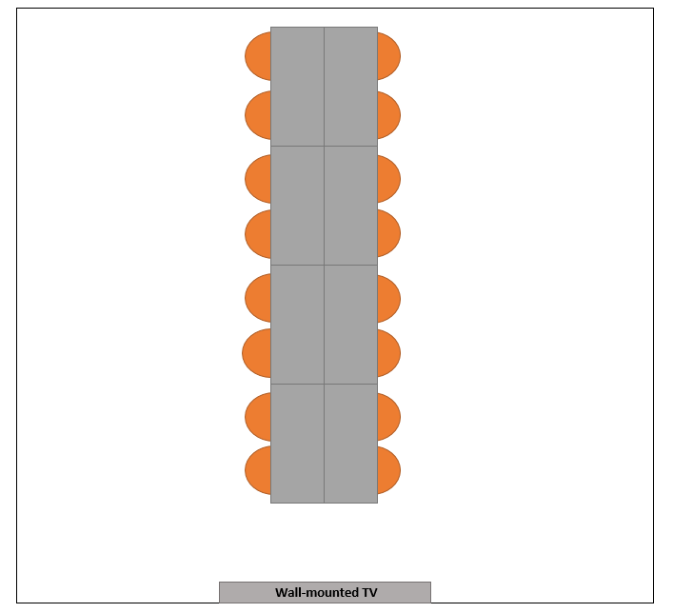

Room Guidelines

General Guidelines on Website
The General Guidelines for the Community Room that are available on the bank’s website and are to be used with the Booking Confirmation Template and the Reminder Template are located on the N drive/Community Room/Other Information/Community Room Welcome_Website.

In Room Guidelines
The In Room Guidelines for the Community Room that will be available in the Community Room are located on the N Drive/Community Room/Other Information/Community Room Welcome_In Room.

In Room Device Guide
A guide on how to connect to the TV is available in the Community Room and is also located on the N Drive/Community Room/Other Information/Connecting to the Presentation Pod_Community Room

Room Contacts
Name | Role | Contact Number
Hanna Sanders | Community Room Administrator | 413-686-4495 (cell)
Dan DeAngelis | Facilities | 774-245-0680 (cell)
MaryAnn Clemente | Conference Room Coordinator | 978-567-3502 (office)
Neil Buckley | Emergency Citadel Contact | 978-340-5471 (cell)

